**120A3051**

**Shreya Idate**

**Batch: E3**

**Experiment No: 9**

**AIM**: To learn Dockerfile instructions, build an image for a sample web application using Dockerfile.

**THEORY**:

Docker also gives you the capability to create your own Docker images, and it can be done with the help of Docker Files. A Docker File is a simple text file with instructions on how to build your images.

FROM keyword tells Docker, from which base image you want to base your image from. In our example, we are creating an image from the Ubuntu image.

The next command is the person who is going to maintain this image. Here you specify the MAINTAINER keyword and just mention the email ID.

The RUN command is used to run instructions against the image. In our case, we first update our Ubuntu system and then install the nginx server on our Ubuntu image.

The last CMD command is used to display a message to the user.

**Create a file with a name as Dockerfile:**

root@it77-OptiPlex-3050:/home/it77/dockertutorial# nano Dockerfile

FROM ubuntu:latest # Adding a layer of Ubuntu as a base image

MAINTAINER "BUSHRA" # Adding an author

RUN apt update –y # Adding a layer of ‘apt-update’ in our image

RUN apt install nginx –y # Adding a layer of ‘nginx’ webserver in our image EXPOSE 80 # Exposing port 80 of web server

COPY index.html /var/www/html/index.html # Hosting our web page / application CMD ["nginx", "-g", "daemon off;"] # Starting nginx webserver in foreground

root@it77-OptiPlex-3050:/home/it77/dockertutorial# docker build -t siesnginxservers .

root@it77-OptiPlex-3050:/home/it77/dockertutorial# docker run -itd -p 8989:80 siesnginxservers root@it77-OptiPlex-3050:/home/it77/dockertutorial# ufw allow 8989

Open browser and put IP/localhost with port number as 8989 and run your web application.

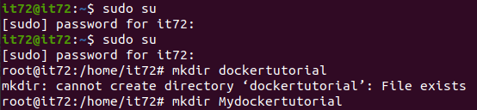

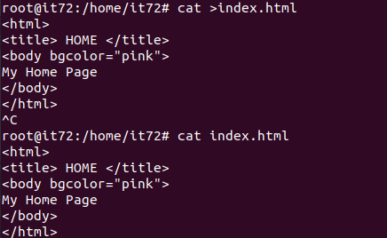

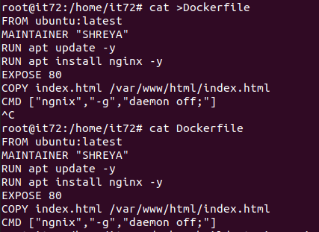

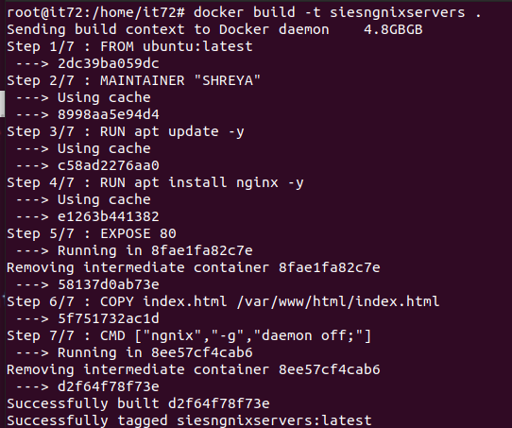

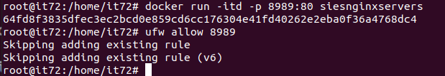

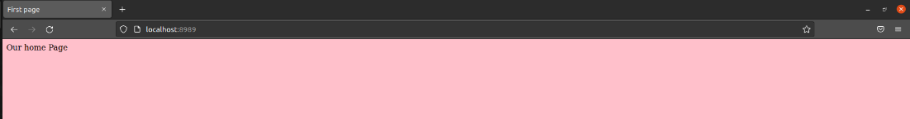

**CONCLUSION:** Successfully learnt Dockerfile instructions, built an image for a sample web application using Dockerfile.